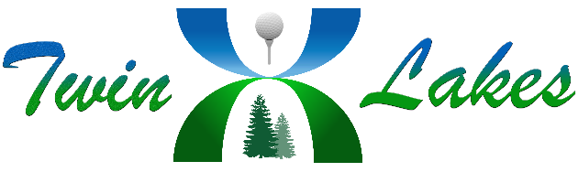
Twin Lakes Homeowners Association
Public Budget Informational
April 15, 2026
Draft

Board Members Present: Tim Walls, Leslie Rose, Craig Brown, Ray Faccenda, Tom Brunner, Greg Glazner, Kathy Franklin, William Herbert and Donovan Barton
Board Member Excused Absence: None
Homeowners Present: Russ Field, Tricia Arbogast, Scott Dornan, Phyllis Mills and Shelly Buehle
Bell Anderson Association Manager: Gayle Duff
Meeting Called to Order at 5:01 PM by Greg Glazner
Treasurer Greg Glazner’s Presentation:
- The key dates of the budget cycle were discussed {next budget informational meeting on June 17, 2026, board approval of 2027 budget in July 2026 and membership approval at the September 2026 annual meeting}.
- Fund overview and explanation {Operating, Capital and Replacement Reserve}.
- Twin Lakes vs. Fairwood HOA dues, differences and similarities was discussed.
- Types of expenses were discussed {fixed, regular and variable}.
- Inflationary pressures impacting the 2027 budget were discussed.
- Key forecasted line-item expenses for the 2027 budget were discussed.
- Planned projects impacting the budget in 2027 and the current financial health of the HOA were discussed.
- A budget surplus of $13,812 is forecasted for 2027 based upon the current draft budget analysis.
.
Meeting was adjourned 6:20 PM

