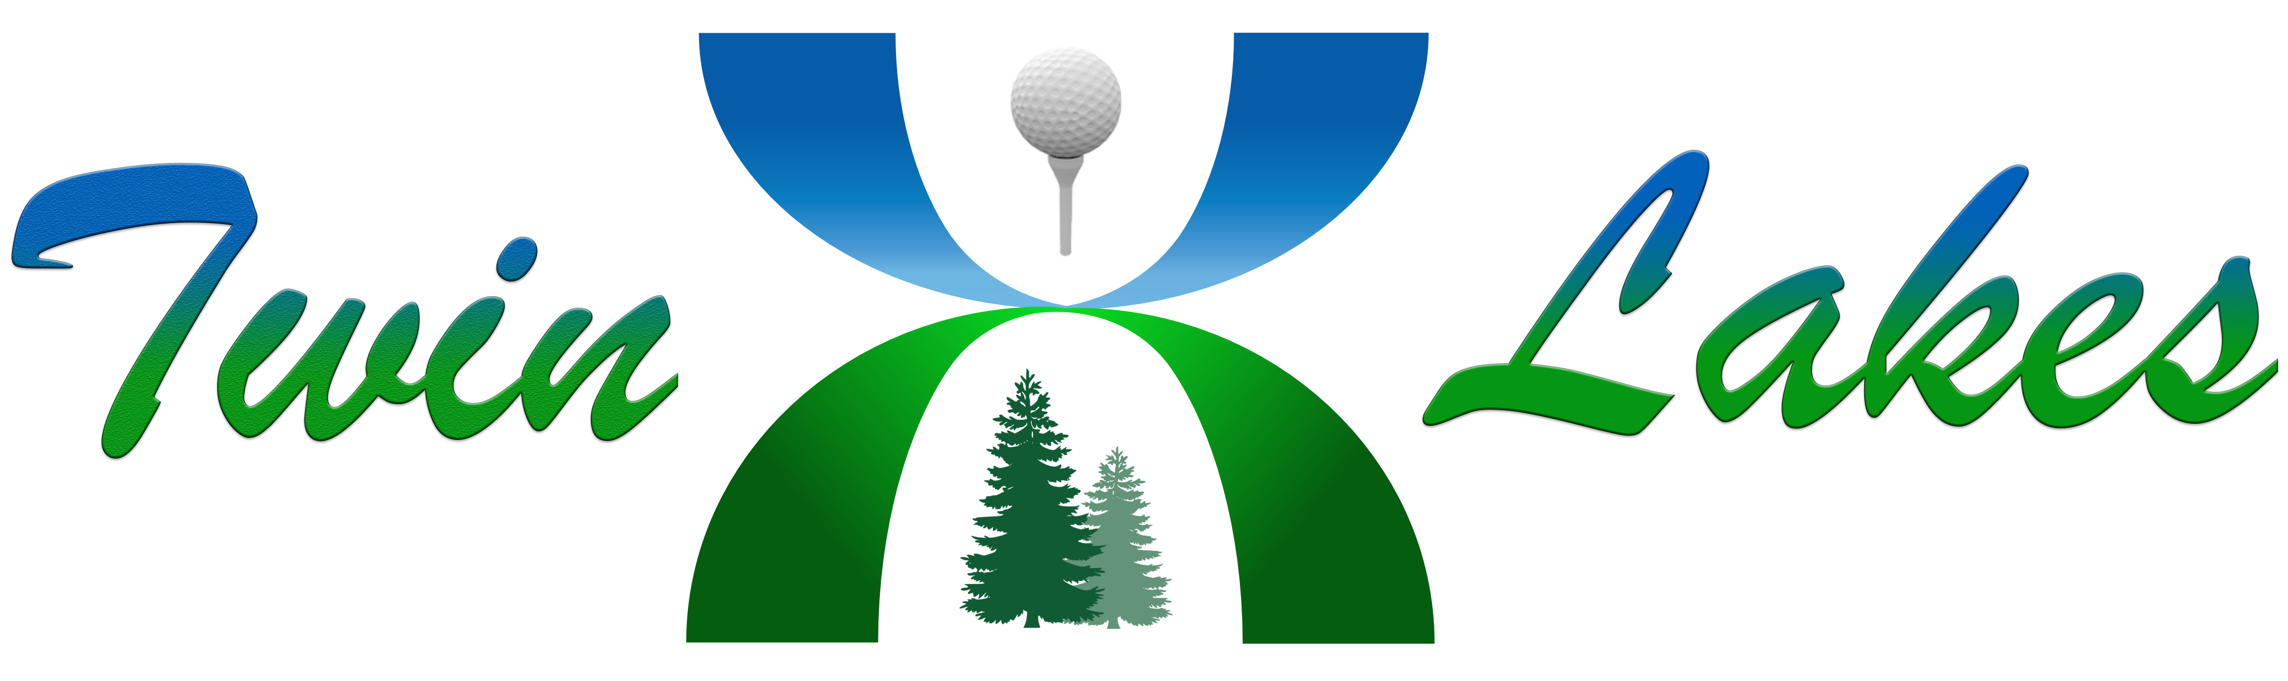
Homeowners Association, Inc.
3420 S.W. 320th, Suite B-3  Federal Way, WA 98023-2209
Phone: (253) 838-0464

Park Party Form

The Twin Lakes Hoa parks are private parks, owned and maintained by the Twin Lakes Homeowners Association for the enjoyment of all its members. If you are a Twin Lakes HOA owner and are planning a special event at the park, please fill out and submit this form prior to your event.

Name of Group Type of Function_________________________________

Date and Time of event ________________
Number of People Attending ______________

TL Homeowner Name
Address
Phone #
Email ________________________________

Although there is no deposit required, any damage or cleanup required will be charged to the homeowners account, that is hosting the event.
Rules:

- The sponsoring homeowner must be present during the event and will be responsible for their guests.

- No inflatables, petting zoo animals or motorized vehicles are allowed in the parks.

- Sponsoring owner must clean up all debris. You may use the trash cans in the park if you do not fill them more than half full. If you have more trash than this, you must take it with you when you leave the park.

- Open fires are not allowed in the parks.

- Other Twin Lake Homeowners may use any part of the park during your function.

Owner responsibility: Homeowner Signature ______________________________________________

